**Architectural Representation**

The top-level architectural style being used for this system is “Layered Architecture”. In layered architecture, the system is separated into several levels, in which related functionalities are grouped together and associated to a single layer. Each layer provides its services to the layers above it, thus the lowest level would represent core services likely to be used throughout the entire system. In the system being created, 3 main layers were defined: The user interface, application logic, and database access/network communication. The lowest layer, Database access, serves as a way to provide information to all layers above it (Application logic layer in order to access data and perform calculations, User interface layer to display information to the user). The next layer, the application logic level, uses data pulled from the database in order to fulfill request generated by the user (e.g.: Viewing their reservations, making a new reservation). Additionally, any manipulation of information would occur at this level. The topmost layer, the user interface level, serves as the primary method for interacting with the system as a whole. No logic occurs at this level, but instead allows for the generation of signals. These signals notify the application logic layer of what needs to be done, which then accesses the database layer to pull the required information.

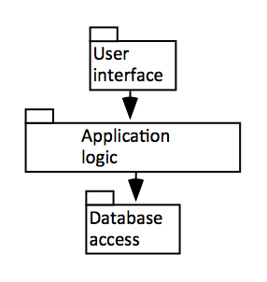

Figure 1: Layered Architecture Design for the System

The view model being adopted is the 4+1 view, in which the system is described from the point of view of multiple different stakeholders. 5 main views are presented below: Logical, Development, Process, Physical, and Use Case. In addition to their appropriate visual representations (in the form of various diagrams), each view will include a description of the purpose it serves with regards to the system as a whole, and who they are appropriate for.

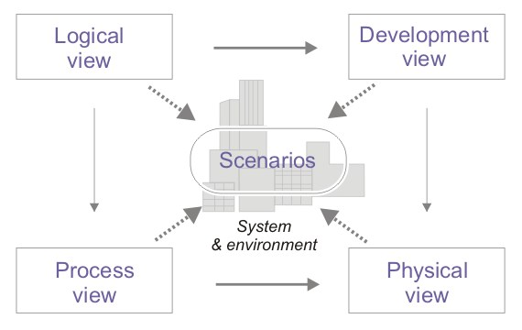

Figure : From SAD doc